1 **Information Sources**

1.1 Medicine Dispenser

1.1.1 Background:

More than 50% of the older people are living with multiple chronic illnesses[1]. Thus, routine monitoring and assessment of the individual’s adherence is crucial to improve their health outcomes. Elderly with multiple chronic conditions face the complex task of medication management that can involving multiple medications of varying doses at different times. Advances in telehealth technologies have resulted in home-based devices for medication management and health monitoring for the elderly.[2] The function of such medication dispensers is to alert the patient when it is the date and time to take their prescribed medication[3]. When the time comes to take the medication, the pill dispenser automatically releases a pre-measured dose for consumption.

1.1.2 Medical Dispenser Standards:[4]

* Provides audible, visible or vibration alerts.
* Dispenser must be locked once medicine is replenished.
* Long distance connectivity to track use.
* Humidity resistant and tamper proof.
* Dispense only the prescribed amount at the required times.

1.2 Telepresence Robot

1.2.1 Telepresence Robot Standards:

Telepresence Robots are a very new and unique type of robot in the market nowadays, and since there are standards for collaborative industrial robots (Cobots) and AGVs (automated guided vehicles) our robot would not be included in such standards because 1) Our robot does not include a robotic arm so it is not considered an collaborative industrial robot and 2) Since our telepresence robot will be a simplified version of our competitors due to our budget restriction, we will not be adding any obstacle avoidance sensors, instead, the person controlling the robot is responsible for its movement, thus it cannot be considered and AGV either. The standards we have to abide by will therefore be our electronic components such as battery and CPU, but since we will buy our batteries and CPU from third party manufacturers (already passed safety regulations and standards) we will not have to worry about any hazard as long as we use the equipment correctly according to the manufacturers.

**2 Project Plan**

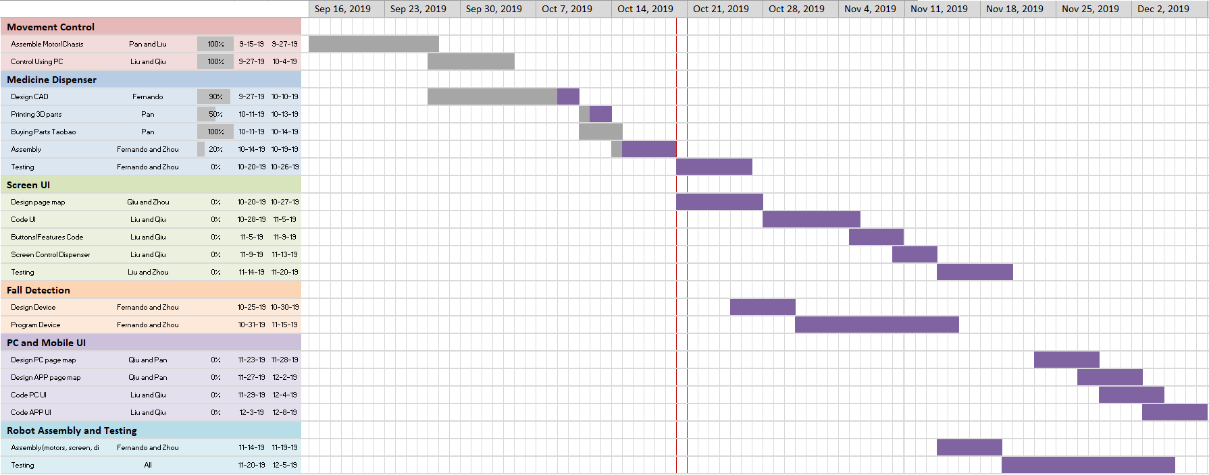

Figure 1: Complete Gantt chart

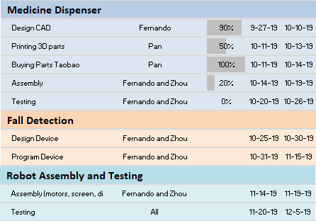

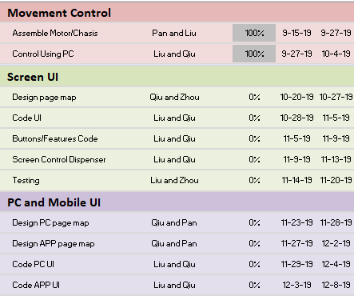Figure 2: ME Tasks and Responsibilities from Gantt chart

Figure 3: ECE Tasks and Responsibilities from Gantt chart

From our complete Gantt chart in Fig 1. we can see the groups progress with our tasks. We are prioritizing the robots functionality such as smooth movement, medical dispenser and fall detection, therefore these tasks are towards the earlier weeks. While our user friendly interface although very important is left for the later weeks since it is not an integral part of the project.

Our progress so far has been acceptable, although we are a little behind schedule with the medical dispenser, movement control has been completed and we are satisfied with the results. We are also getting ready to start work on our screen UI and fall detection tasks. We should have no problem in being able to deliver a finished product with all its working specifications by the end of the semester.

**3 Conclusions**

1. Yap, A.F.; Thirumoorthy, T.; Kwan, Y.H. Systematic review of the barriers affecting medication adherence in older adults. *Geriatr. Gerontol. Int.* **2016**, *16*, 6993–7001.
2. Reeder, Blaine, et al. “Older Adults' Satisfaction with a Medication Dispensing Device in Home Care.” *Informatics for Health & Social Care*, U.S. National Library of Medicine, Sept. 2013, www.ncbi.nlm.nih.gov/pmc/articles/PMC4122419/.
3. Sumo Guide. “Best Automatic Pill Dispenser - Top 10 Reviews 2019.” *Sumo Guide | The Ultimate Shopping Guide & Product Reviews*, Sumo Guide Team Https://Sumoguide.com/Wp-Content/Uploads/2016/09/Sumo-Guide-Logo-300x100.Png, 31 July 2019, sumoguide.com/best-automatic-pill-dispenser-reviews/.
4. American Society of Health-System Pharmacists. ASHP guidelines on the safe use of automated dispensing devices. Am J Health-Syst Pharm. 2010; 67:483–90.